Ref – Furukawa S, Nishi K, Morita S, Hitosugi M, Wingenfeld L. The damaging in the granular cells and expression patterns of CIRBP, RBM3, HSP70, HIF-1, AIF1, SIRT1,Ngb, cFos, p53 and CCC9 in the postmortem human cerebellums obtained from individuals who died due to hanging, strangulation, drowning, or asphyxia by anaphylaxis or food aspiration may be closely linking with agonal duration. Anil Aggrawal's Internet Journal of Forensic Medicine and Toxicology [serial online], 2015; Vol. 16, No. 1 (Jan - June 2015): [about 18 p]. Available from: http://anilaggrawal.com/ij/vol_016_no_001/papers/paper005.html. Published as Epub Ahead : Sep 30, 2014.

Access the journal at - http://anilaggrawal.com

*************************************************************************

Title
The damaging in the granular cells and expression patterns of CIRBP, RBM3, HSP70, HIF-1, AIF1, SIRT1,Ngb, cFos, p53 and CCC9 in the postmortem human cerebellums obtained from individuals who died due to hanging, strangulation, drowning, or asphyxia by anaphylaxis or food aspiration may be closely linking with agonal duration

S Furukawa, K Nishi, S Morita, M Hitosugi, L Wingenfeld *
Department of Legal Medicine, Shiga University of Medical Science, Setatsukinowa-cho, Otsu, Shiga, Japan
* Institute of Legal Medicine, Munich University, Munich, Germany

Satoshi Furukawa, MD

Department of Legal Medicine, Shiga University of Medical Science,

Setatsukinowa, Otsu City, Shiga 520-2192, Japan

TEL & FAX: +81-77-548-2200,

E-mail. 31041220@belle.shiga-med.ac.jp

Abstract

We encountered several cases concerning to ischemic and hypoxic deaths at

routine autopsy cases. These victims were individuals who died due to

suicidal hanging, autoerotic accidental hanging, self-ligature strangulation,

manual strangulation, strangulation by a rope, accidental and suicidal

drowning, anaphylaxis shock, and asphyxia by food aspiration. Theiragonal

duration and postmortem interval were different, that is, agonal duration

distributed from direct death to 4days and postmortem interval was from

12hours to 40 days, respectively. We examined the damaging degree of the

granular cell layer in the each cerebellum using an application of Photshop

andexpression pattern of antigens in the cerebellums by

immunohistochemstry using anti CIRBP, RBM3, HIF-1, AIF1, SIRT1, Ngb,

HSP 70, cFos, p53 and CCC9 antibodies. The results indicate the

co-relationship between damaging of the granular cells and agonal duration,

andshowed that expression pattern of antigens may be relate with agonal

duration, although it was not significant. The antigens expressed during

agonal duration might be kept even in postmortem interval. In a special case

in which an individual was killed and buried for 40 days under ground after

being strangulated, the antigens related to stress and ischemic signaling

pathway such as HSP70, CCC9, CIRBP, RBM3 and SIRT 1 were detectable

in the molecular layer and dentate nucleus of the cerebellum. The

co-relationship between the damaging of granular cells and agonal duration

may be more reliable compared with those of Purkinje cells and agonal

duration. The results obtained in this study indicate that the damaging of

granular cells is useful tool to estimate agonal duration, and postmortem

humanbrain tissue may be utilizable for diagnosis and examination of brain

diseases. The results obtained in this study indicated that CIRBP and RBM3

were hypoxic or ischemic related antigens and not the cold inducible

antigens.

Key Words: Cerebellum, Purkinje cells, Granular cell layer, Dentate

nucleus, Hypoxia, Ischemia, CIRBP, RBM3, SIRT1, Ngb, CCC9 and HSP 70

Introduction

The cells could bring their action to protect harmful effects assigned by the

environmental items. Although cerebral ischemia occurs in the context

either of focal reduction in blood flowing to the brain regions and/or cerebral

infarction, a global deficit status occurs only in animal study. However the

global deficit actually occurs in forensic practical cases such as hanging,

strangulation, food aspiration, drowning death and/or anaphylactic reaction.

The brain is vulnerability to ischemic and hypoxic status. It is widely

accepted that in hypoxia and ischemic cases an increase in the transcription

level of specific genes, including those encoding for hypoxia-inducing factor

1(HIF1)(1,2), apoptotic inducing factors (AIF-1) (3), and stress related factors

containingCold inducing RNA binding protein (CIRBP)(4)and RNA binding

motif 3 (RBM3)(5) which are recognized as a cold stress inducing protein and

were intensively expressed in the postmortem human heart muscle obtained

from accidental hypothermic death cases (6). Neuroglobin (Ngb)(7),

Complement component C 9(8,9), c-Fos(10), Protein 53(p53)(11), Sirtuin 1

(SIRT1)(12) andHeat shock protein 70(HSP70)(13) were also expect to

express in the hypoxia or ischemic cerebellum.

The morphological and histological changes recognized in the cerebellums

obtained from brain death cases have been investigated around 1990 (14),

howeverimmunohistochemical studies using antibodies against apoptotic-,

stress-, necrotic- and/or hypoxic-related antigens are rare until recent. We

have been performing the forensic autopsy as a routine working and

encountered several suicidal hanging and self-ligature strangulation cases in

which there are directly, acute, sub-acute and prolong death individuals (15),

and other deaths due to different types of asphyxia and with different

durations.

Although various studies have been examined the consequences of hypoxia

on cerebellar neurons, a controversy still exists concerning the mode of

toxicity expressed in Purkinje cells following hypoxic insult (16). In the

present study we examined the degree of damaging of granular cellsand

Purkinje cells during agonal time in the first step and the differences among

the expression of stress, hypoxic and apoptotic related antigens described

above were studied in the next step.

Concerning hypoxic changes in Purkinje cell, Hausmann et al(17) studied

using 52 individuals with a history of acute or prolonged cerebellar

hypoxia/ischemia before death. Various and different kind of cause of death

were contained in their study.In this study we examined the relationship

between degree of damaging granular cells and expression pattern of

hypoxia, apoptotic and/or necrotic antigens in the cerebellum obtained from

individuals who died mainly due to compression of cervical arteries.

Concerning to the using of postmortem human brain to investigate the brain

disorder, Sheedy et al (18) proposed that histological situation of cerebellar

granule cell layer is a useful marker of tissue integrity. We also like to

describe some comments on the autolysis of the brain tissue during the

postmortem interval.

Materials and Methods

In this study we selected and examined the cerebellum obtained from

suicidal hanging cases containing direct, sub-acute and delayed death cases，

self strangulation cases, manual strangulation cases, drowning cases,

anaphylaxis case, and asphyxia case due to food aspiration to the larynx

and/or the trachea. We did not use the cerebellum obtained from patients

who died due to illness such as cardiac infarction, pulmonary diseases, and

or cerebral infarction, since it is difficult to determine the onset of ischemia

or hypoxic state to the cerebellum in these illness. For example, we have one

autopsy case where the granular cells were obviously damaged in 54

year-old-man who died due to cardiac infarction with coronary artery

thrombosis during right in driving his car. The autopsy revealed that he had

been have several times heart attach. Characterization of antibodies used or

examined in this study was summarized in Table 1.
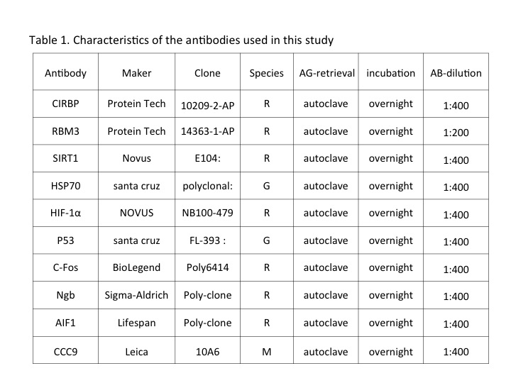

[1] Tissue preparation and analysis of Granular cell Damaging

The tissue sections with about 0.5cm thickness were obtained from the

cerebellum at autopsy, Department of Legal Medicine, Shiga University of

Medical Science. Tissues containing the dentate nucleus, and cerebellar

cortex were fixed in 10% of formaldehyde for 24 hours and embedded in

paraffin. Threeμm of tissue sections were prepared for conventional and

immunihistochemical staining using antibodies described in Table 1. The

staining procedure for immunohistochemistry was followed our previous

report (4).

Damage of granular cell layer was evaluated by an observer blinded to the

group assignment of the section according to the report by our previous

report(19). In shortly the evaluation of alteration of the granular cells was

performed using a Photoshop application. After taking each photograph at

microscopy level the area with blue color in the granular cell layer, that is,

nucleuses of granular cells stained by hematoxylin, was measured by an

application and with same magnification, that is, blue color area indicates

existence of live nuclear of the granular cells. The frequency of remaining

granular cells was indicated as percentage of the total number of pixel and

was grouped. The numerical value was the mean value of five different

areas.

The damage and decreasing of the Purkinje cells was also evaluated by

image analytic technique. The images of cerebellar sections stained by HE

were captured using an objective lens with a magnification of 4. The total

length of the Purkinje cell layer from 8 images from each individual was

calculated using BZ-II Image Analysis Application. And then the number of

the Purkinje cells with nucleus was counted. The existence of the Purkinje

cells was showed a number per 1mm of the Purkinje cell layer.

[2] Cases examined.

Case 1. (Autopsy No.1222)

A 39 year-old woman with depression died due to hanging using a vinyl rope.

Small number of petechea was detected in her conjunctiva, and single

ligature mark was clearly observed. In this case re-perfusion of blood to the

brain was not presumed.

Case 2. (Autopsy No. 1225)

A 38-year-old woman died due to hanging by a rope after she killed her own

son. At autopsy clear ligature mark was found around her neck and ligature

mark indicated typical hanging manner. In this case re-perfusion of blood to

the brain was not presumed, however her postmortem interval was

presumed around two days.

Case 3. (Autopsy No. 58749)

A 74 year-old housewife was found to be hanging by her husband. When the

husband immediately cut the ligature, her body full down and she got a

bruise on the posterior of head. The autopsy revealed the no facial

congestion, multiple costal fractures, bleeding in the fatty tissue in the heart

and left temporal of the head and mild cerebral contusion on the lower part

of both side in frontal lobes. In this case, occlusion of cervical arteries

occurred in a short time, and re-perfusion of blood to the brain might be

performed in a few minutes.

Case 4. (Autopsy No. 1257)

A 45 year-old woman was found her death due to hanging. The body without

clothing except a scanty was standing by a stairs in her house. Her face

showed severe congestion and number of petechea in the conjunctivae was

detected. Her death seemed to be accident due to autoerotic performance.

The autopsy revealed a small amount of bleeding in the right

sternocleidomastoid muscle and no fracture of hyoid bone and thyroid

cartilage. The brain showed congestion and no bleeding. In this case

intermittent occlusion may be occurred during her autoerotic performance.

Case 5. (Autopsy No. 1320)

A 43 year-old man was found in his working car. The body lied on the back

seat of a low displacement car and covered with a blanket. There was a

ligature mark on his neck but no ligature in the car. The result of autopsy

suspected that he attempted suicidal hanging but he could not die because of

snapping a ligature. His death was presumed relayed hanging death, and

agonal duration was presumed two or three hours. Re-perfusion of blood to

the brain obviously was presumed.

Case 6. (Autopsy No. 1255)

A 67-year-old woman performed hanging with sitting position. Although she

carried to a hospital by an emergency car, she died 20 hours after finding of

her hanging. Re-perfusion of blood to the brain obviously was presumed.

Case 7. (Autopsy No. 1117)

A 51 year-old man was found death due to self-strangulation with a cotton

rope in his room. The severe congestion over the ligature mark, and small blisters

were observed between two ligature marks. A large number of petechiea in the

conjunctiva and mouth mucosa was also recognized.Agonal duration presumed to be

longer than hanging death.

Case 8. (Autopsy No. 1239)

A 31 year-old man was found death in a prison room. He wound a sleeve of his T-shirt

around his neck, and severe congestion and petechia on his face, conjunctiva and mouth

mucosa. Agonal duration presumed to be longer than hanging death.

Case 9. (Autopsy No.1254)

A 26 year-old man drowned in a public poor during his diving training and

he was rescued and transformed to a hospital, however he died after 20

hours.

Case 10. (Autopsy No.59458)

A 71 year-old woman japed into a river. After being transformed to a hospital

for rescue and medical treatment, she died two days later.

Case 11. (Autopsy No.1142)

A 54-year-old woman was killed by her acquaintance with manual

strangulation. In one hour after hear death the body was found by her

daughter in her living room. The agonal duration was presumed to be a bit

longer than self-strangulation cases, since it may be occur the defense to

murderer.

Case 12. (Autopsy No.1272)

A 47-yaer-old woman was found under the ground in front of her house.

Police research revealed that her husband killed her with manual

strangulation and after keeping her body in a forest for several days, she had

been burying for about 40 days. At discovering her body, the body was

rapped with thin plastic film and covered with plastic seat.The agonal

duration was presumed to be a bit longer than self-strangulation cases,

however the postmortem interval was longest in this examination.

Case 13. (Autopsy No.1242)

A-51-year old woman fell into anaphylaxis shock by intake of barium salt for

stomach examination, and she died after 4 days in an emergency hospital.

Case 14. (Autopsy No.1359)

A 53-year old man was found death. Autopsy revealed that food mass

entered to larynx and he died due to accidental ingestion. His agonal

duration was presumed to be several minutes.

The postmortem interval of each case was within4 days except one

individual from case 12.

Results

The damaging in the granular cells and Purkinje cells of each individual was

described in Table 2, and results obtained by immunohistchemistry were

listed in Tables3-1 and 3-2.
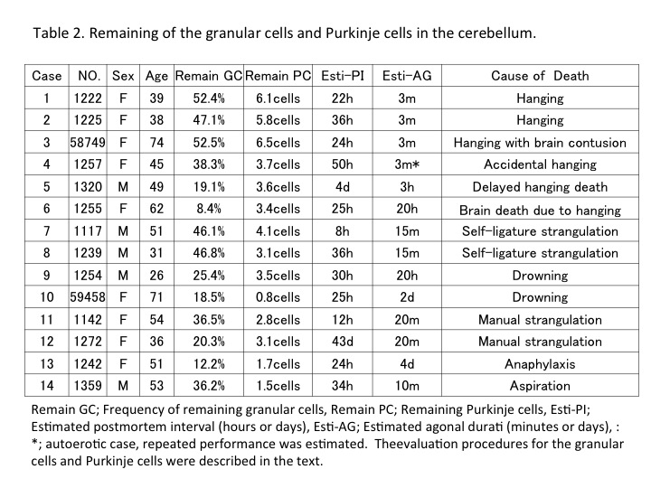

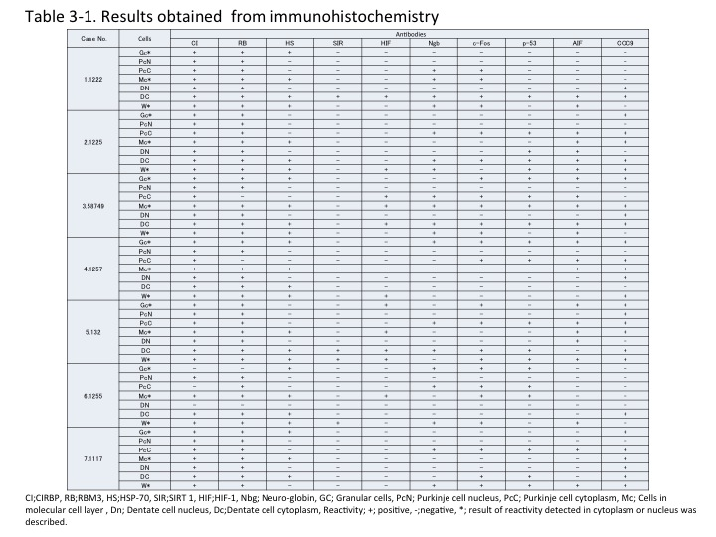
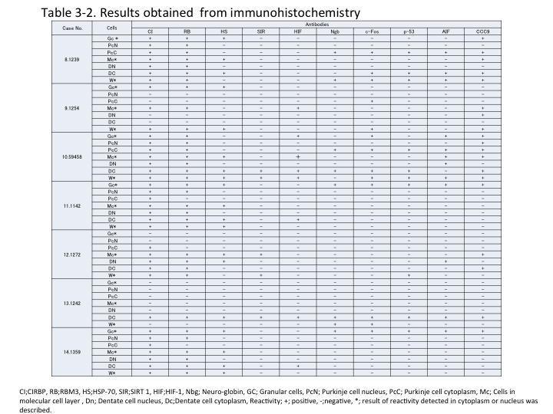
1. Granular cells

[1]Hematoxylin-Eosin staining

In the granular cell layer the morphology was different, that is, complete

disappear of cells with cell debris or fibrous material in some individuals,

remarkable decreasing of cells in other individuals and numerous remaining

cells in another individuals. For example, the granular cell layer from severe

level degeneration individuals showed a diffuse decrease in number the

nuclei stained by hematoxylin and diffuse pallor of the background without

glial reaction and with cell debris as shown in Figure 1, and the changes in

high remaining individuals were not obvious and showed no remarkable

difference compared with those from brain injure deaths due to traffic

accidents (date not shown). 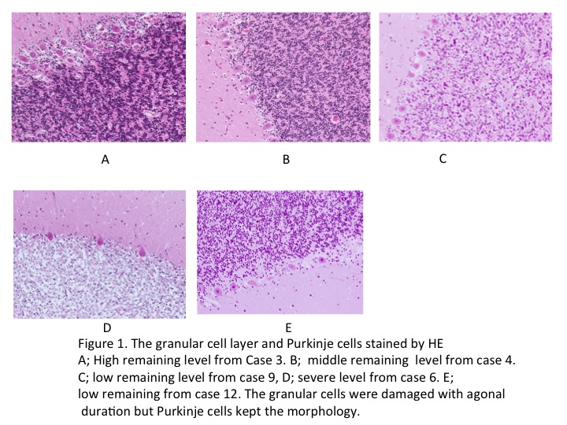

The results obtained from evaluation of the

damaging of the granular cell layer using an application of Photo-shop were

listed in Table 2. The frequency of remaining granular cells was indicated as

percentage of the total number of pixel and classed into four degrees, that is,

high remaining level; over or around 50% of cell was stained by hematoxylin,

middle remaining level; from 30 to 40% of the cells were stained, low

remaining level; around 20% of cells were stained, and severe degeneration

level; around 10% of cells were remained with large amount of cell debris

(synaptic glomeruli). Case 1,2,3,7,and 8 were grouped into high remaining

level, case 4,11 and 14 were in moderate group, case 5, 9, 10 and 12 were in

low group and case 6 and 13 were grouped into severe level. As an

interesting case, the granular cell layer of the cerebellum obtained from case

12 individual whose postmortem interval was presumed over 40 days,

decreased the stain-ability, however the morphology of the granular cells

have been well keeping compared with the longer agonal duration cases that

was classed into severe level.

Changing of granular cell layer was remarkable compared with that of

Purkinje cells in lower and severe level groups where the morphology of

Purkinje cells was still remained.

[2] Immunohistochemical staining

In the granular cell layer at high level remaining, a large amount of granular

cell nucleus showed good and intensive reactivity with anti CIRBP and

RBM3 antibodies. HSP70 showed weak or no reactivity with the nucleus of

the granular cells, however it showed good reactivity with cytoplasm and

synaptic glomeruli of some cells, presumed Golgi cells and Lugar cells in the

granular cell layer and the Purkinje cells layer, respectively. Antibodies

againstcFos, AIF1, p53, Ngb and CCC9 showed weak reactivity with

cytoplasm of the granular cells and in the synaptic glomeruli of the granular

cell layer. The synaptic glomeruli showed just like cell debris.

The granular cells at middle remaining level showed moderate reactivity

with anti RBM3 antibody and weak reactivity with CIRBP antibody in the

nucleus, and anti HIF1, SIRT1 and Ngb showed no reactivity with the

granular cells at middle remaining level. There is slight reactivity between

cell debris, synaptic glomeruli, with anti CIRBP, RBM3, HIF1, SIRT1 and

Ngb in the granular cell layer at low level remaining.

2. Purkinje cells

[1]Hematoxylin-Eosin staining

The Purkinje cells showed various changes such as disappear, shrunken

eosionophilic cytoplasm with smudgy dark nuclei, or vacuolated,

homogenous, eosinophilic or pale cytoplasm with pale or piknotic nuclei.

The Purkinje cells exhibited homogeneity in color and shape at high

remaining level. With decreasing of the cells in the granular cell layer, the

degeneration of Purkinje cells was also progressed. Purkinje cells from case

12 remained the morphology with normal nucleus in many cells, although

staining ability was decreased.

[2]Immunohistochemical staining

Purkinje cells in the cerebellum at high remaining level showed clear

reactivity with anti CIRBP both in the nucleus and cytoplasm, and intensive

reactivity with RBM3 only in the nucleus (Figure 2).

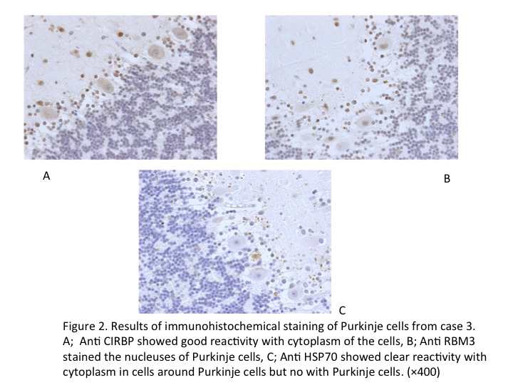

Anti cFos, Ngb and

CCC9 showed weak reactivity with cytoplasm and no with nucleus. Anti

HSP70 showed good reactivity cytoplasm in the cells around Purkinje cells

(Figure 2), however, reactivity of the antibody with cytoplasm in the

Purkinje cells decreased with progression of damaging of granular cells.

Purkinje cells at middle remaining level showed slight reactivity with

CIRBP in cytoplasm and clear reactivity with anti RBM3 in the nucleus.

Although no reactivity with anti HIF1, SIRT1 and CCC9 was recognized,

antiNgb, cFos and HSP antibodies showed weak reactivity in the cytoplasm

of some Purkinje cells.

Purkinje cells at low remaining level showed no reactivity with anti CIRBP,

RBM3, HIF1, and SIRT1, however anti CCC9 (Figure 3), Ngb, cFps and

HSP, showed weak reactivity with cytoplasm of some Purkinje cells which

were keeping the morphology.

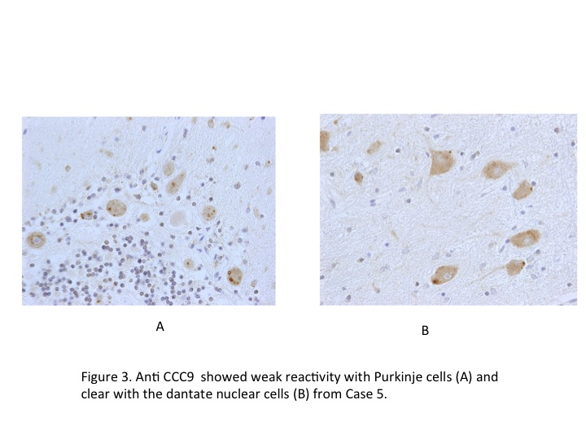
3. Molecular layer

[1]Hematoxylin-Eosin staining

The cells in the molecular layer were detected even in individuals with

severe decreasing level of granular cell layer, although the number of

remaining cells was decreased, however it was difficult to identify the basket

or satellite cells.

[2] Immunohistochemical staining

At high remaining level the nucleuses of many cells in the molecular layer,

but not all cell, showed intensive reactivity with anti CIRBP and RBM3, and

moderate reactivity with anti HSP. Although weak reactivity with cells and

anti CIRBP, RBM3, HSP and cFos antibodies was recognized at low and

middleremaining level, anti HIF1 and Ngb showed no reactivity with the

cells. At moderate and low remaining level anti SIRT 1and CCC9 stained

weakly with nucleus of some cells in the molecular layer but not all cell. At

severe level weak reactivity of CIRB, RBM3, cFos and HSP with the nucleus

of the some cells was detected and no or feeble with other antibodies.

4. Cells in the Dentate Nucleus

[1]Hematoxylin-Eosin staining

With the progressing of the agonal duration, the degeneration of the dentate

nuclear cells increased. However cells were able to keep the morphology even

in severe level cases where it was difficult to detect the cell nucleus.

[2]Immunohistochemical staining

Anti CIRBP, RBM3 and HSP showed intensive reactivity with cytoplasm of

the dentate nucleus cells at high remaining level, the reactivity with these

antibodies decreased with increasing of damaging of the granular cells,

however weak reactivity with all antibody (Figure4), except anti HIF1,

examined in this study was kept even in severe damage level of the

cerebellum obtained from Case 6 whose evaluation numerical value was

calculated at 8.4%.
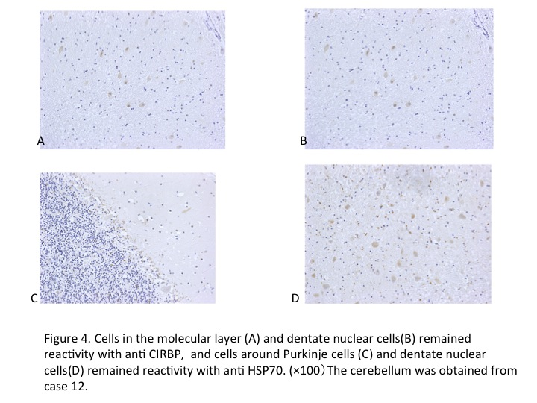

Anti SIRT 1 showed moderate reactivity with the cell nucleus around the

dentate nucleus and cytoplasm of the dentate nucleus cells at moderate

remaining level.

5. The cells in the white matter

[1]Hematoxylin-Eosin staining

The cells in the white matter of the cerebellum were remained even in severe

level individuals, although their number was remarkably decreased.

[2]Immunohistochemical staining

Anti CIRBP, RBM3, HSP70 and cFos antibodies showed weak reactivity

with nucleuses and cytoplasm of the remaining cells even in the severe level

individuals. Anti AIF1, SIRT1 and Ngbalso showed weak reactivity with the

cytoplasm of the remaining cells in severe damaged level individuals,

however, reactivity with HIF1 was not detected.

Some cells such as cells in the dentate nucleus cells and molecular layer in

the cerebellum from case 12 remained weak reactivity with anti CIRBP,

HSP70 and CCC9 as shown in Figure 4.

Discussion

In this study could indicate that many antigens are expressed during agonal

duration as the vital reaction or biological reaction of the bodies. In forensic

field it is known as the obvious evidence that the pressure ulcer could occur

during alive and not occur or not become more seriously after one’s death.

Concerning to agonal duration in hanging cases, Sauvageau et al (20)

reported that the death occurred at 4mintes 12 seconds±２minutes 29

seconds, and in our experience the death occurred at 2mints 38seconds (21).

Since in typical hanging case both side of carotid and vertebral arteries are

obstructed, the death comes earlier than other death due to

self-strangulation and/or manual strangulation.

The brain is critically dependent on its blood flow for a continuous supply of

oxygen and glucose. Only a few minutes of severe ischemia induce the

selective degeneration of certain neuronal populations, including pyramidal

neurons in the CA1 region of the hippocampus, neocortical neurons in layers

3,5, and 6, and cerebellar Purkinje cells (22). As describing in a review article

bySarna and Hawkes(23), it is also well known the vulnerability of the

Purkinje cells to severe and transient global brain ischemia, chronic hypoxia

experiments, intermittent hypoxia(24,25), toxic situation (26)and many

neuronal degeneration diseases. This study indicates that the vulnerability

of the granular cells may be more obvious and convenience for analysisthan

that of Purkinje cells, since the changing of granular cell layer was

remarkable and homogeneous compared with that of Purkinje cells in lower

and severe level groups where Purkinje cells was still remained and showed

various changes such as disappear, shrunken eosinophilic cytoplasm with

smudgy dark nuclei, or vacuolated, homogenous, eosinophilic or pale

cytoplasm with pale or pyknotic nuclei, showing difficulty in the evaluation

and analysis.

There was the difference of the degree of damaging in the granular cell layer

between case 11 and 12, although they were killed by manual strangulation

andagonal durations of them were presumed almost the same. The

differencein partly seemed to relate their postmortem intervals. There was

also difference of damaging level among case 6, 10 and 13. This difference

may arise from obstruction of cervical vessels in case 6 and global anoxia in

cases1 10 and 13.

In our previous reports (6), antigens such as CIRBP, RBM3 and SIRT1 were

expressed in the nucleus of the cardiac calls obtained from hypothermic

and/or carbon monoxide intoxication death. In this study, reactivity with

anti-CIRBP and RBM3 antibodies was detected in nucleuses in the cells of

the cerebellum, however that of anti SIRT1 antibody was not detected in the

granular cells and Purkinje cells, although the reactivity was recognized in

the cytoplasm of the dentate nucleus cells of the cerebellum. The same result

was observed in the cerebral cortex (15), indicating that expression of SIRT1

which plays important role to protect the brain function from many stress

(27)may be most delayed one in the brain.

It is well known that CIRP and RBM3 were discovered after exposure to a

moderate cold-schock and other cellular stress such as UV radiation and

hypoxia(28). Although at normal temperature, CIRBP mRNA expression

was detected in the rat brain(29), Wellmann et al (30) reported that hypoxia

significantly induced CIRBP and RBM3 expression in vitro. We also reported

that intensive reactivity of anti CIRBP and RBM3, weak reactivity of HIF1

and HSP-70 and no reactivity with SIRT1 in the nucleus in the neuron of the

frontal cortical region obtained from two male who died suicidal

strangulation using a rope or T-shirt were detectable (15). These results

indicate that CIRBP and RBM3 may be ischemic and/or hypoxic related

antigens, although these antigens were discovered as the cold inducible

antigens.

HIF-1 is a hypoxic inducing factor and detected in hypoxic tissues (1), and

oxygen-regulated expression of CIRBP and RBM3 by a HIF-1-independent

mechanism was reported usingthe human leukemic cell line (30), however in

this study HIF1 could show weakor feeble reactivity with Purkinje cells

and confirm the repot from Wellmann et al (30). Chen et al (12) reported a

bidirectional link of HIF and Sirt1 signaling during hypoxia, and then weak

reactivity of HIF and Sirt 1 in the celebbellum may be caused by the linkage

of the genes encoded expression of HIF and Sirt 1 in the this organ.

Concerning the expression of HSP70 many studies were reported, and the

expression of HSP70 in Purkinje cells reduced in patients with schizophrenia

compared with individual without disease (31). In this study the expression

of HSP70 was not detected in Purkinje cells, although the clear expression of

the antigen in the cells was recognized in Purkinje cell layer, granular cell

layer, molecular layer, dentate nucleus, and cerebellar white matter. In our

previous experience (15), reactivity with HSP70 and neurons in the cerebral

cortex was remarkably detected in the case 7 and 8 of this study.These

results may cause by the difference of stability against the stress among the

cells, indicating that the HSP70 expression system in Purkinje cell is most

vulnerability, different among the brain lesions or early disappear in the

cells.

Schaefer et al (32) described deposition of C5b-9 complexes can already occur

at the cytoplasmic membrane surface of ischemic cells, and

immnocytochemical detection of C5b-9 provides a powerful tool for detecting

even single cell necrosis in the cardiac infarction cases. In this study the

reactivity of CCC9 was detected mainly in the cytoplasm of the dentate

nucleus cells. The cells stained by anti CCC9 may be in necrotic stage and

shows the latest stage in the cell biological reaction against ischemic,

because some heart cells were stained by CCC9 and other cells with normal

morphology did not show the reactivity in acute cardiac infarction cases.

In this study the Purkinje cells seemed to be destroyed with increasing of

disappearing of granular cells and showed clear difference in the expression

pattern of CIRBP and RBM3, that is, CIRBP showed its reactivity in the

cytoplasm and RBM3 was detected in the nucleus of the Purkinje cells at the

level of normal stainability of granular cells. This phenomenadiffer from

those in the heart muscle in which these antigens were expressed mainly in

the nucleus of the cells affected in hypoxic situation (6).This result indicates

that the difference in the expression of these antigens exists among the

organs.

Conclusion

The results obtained in this study indicate that the intracellular distribution

of each antigen confirmed the previous reports. The intercellular distribution

of each antigen was different in the cerebellum. The expression of hypoxia,

ischemia, apoptotic and necrotic related antigens may be expressed

according to each encoded gene during agonal duration and the activity of its

expression, cascade of antigen expression pathway, may be stopped at

cellular death and situation of expressed antigen and cell morphology would

be kept even in postmortem interval when there was no putrefy of the body.

The cells in the dentate nucleus and white matter may be most stable to the

changing during agonal duration and postmortem interval. The evaluation of

granular cell layer might be useful to presume the agonal duration,

confirming to the report described by Sheedy et al (18), however, we should

know that the granular cells were kept their morphology for a long time in

special situation such as under ground.

The present study indicates that once vessel occlusion has occurred, the

concerned tissue depleted of blood supply undergoes causing neuronal injury

and many signal pathways are activated leading to cell death, immune, and

other responses, and also indicates that the results by cascade of signal

pathways may be kept the situation that the each cascade was stopped. This

phenomenonresembles to pressure ulcer (decubitus), that is, the pressure

ulcer never newly becomes in postmortem interval.

Acknowledgements

Partially supported by JSPS KAKENHI Grant Number 26460876.

References
1). Wang G L, Rue E A, Semenza G L, Hypoxia- inducible factor 1 is a
basic-helix-loop-helix-PAS hereodimer regulated by cellular O2 tension. Pro
NatlAcdSci USA, 1995; 92: 5510-5514.
http://www.ncbi.nlm.nih.gov/pubmed/7539918
2).Smith T G, Robbins PA, Ratclife PJ, The human side of hypoxia-inducible
factor, Br,J.Haematol, 2008; 141: 325-334.
http://www.ncbi.nlm.nih.gov/pubmed/18410568
3). Joza N, Susin SA, Daugas E, Stanford W L, Cho S K, Li C Y, Sasaki T,
Elia A J, Cheng H Y, Ravagnan L, Ferri K F, Zamzami N, Wakeham A,
Hakem R, Yoshida H, Kong Y Y, Mak T W, Zuniga-Pfluecker J C, Kromer G,
Penninger J M, Essential role of the mitochondrial apoptosis-inducing factor
in programmed cell death. Nature 2001; 6828: 549-554.
http://www.ncbi.nlm.nih.gov/pubmed/11279485
4). Nishiyama H, Higashitsuji H, Yokoi H, Itoh K, Danno S, Matsuda T,
Fujita J, Cloning and characterization of human CIRBP.cold-inducible
RNA-binding protein cDNA and chromosomal assignment of the gene. Gene,
1998; 204: 115-120.
http://www.ncbi.nlm.nih.gov/pubmed/?term=Cloning+and+characterization+of+human+CIRBP.+cold-inducible+RNA-binding+protein+cDNA+and+chromosomal+assignment+of+the+gene.
5). Derry J M, Kerns J A, Francke U, RBM3, a novel human gene in Xp11.23
with a putative RNA-binding domain, Hum Mol Genet 1996; 4: 2307-2311.
http://www.ncbi.nlm.nih.gov/pubmed/?term=RBM3%2C+a+novel+human+gene+in+Xp11.23+with+a+putative+RNA-binding+domain
6). Furukawa S, Wingenfeld L, Sakaguchi I, Nakagawa T, Takaya A, Morita
S, Yamasaki S, Nishi K, Histopathological characteristics of human cardiac
tissues in accidental hypothermia using immunohistochemistry;
Immunohistochemical detections of cold, hypoxia and apoptotic related antigens are practicable in the myocardium from hypothermic death even in
postmortem examination, Anil Aggrawal’s Internet Journal of Forensic
Medicine and Toxicology, 2013;
http://www.anilaggrawal.com/ij/vol_014_no_001/main.html
7). Burmester T, Hankeln T, What is the function of neuroglobin, J Exp Biol, 2009; 212: 1423-1428. http://www.ncbi.nlm.nih.gov/pubmed/24811692
8). Fracasso T, Pfeiffer H, Michaud K, Koehler H, Sauerland C, Schmeling A,
Immunohistochemical expression of fibronectin and C5b-p in the
myocardium in cases of carbon monoxide poisoning. Int J Legal Med, 2011;
125: 377-384.
http://www.ncbi.nlm.nih.gov/pubmed/?term=Immunohistochemical+expression+of+fibronectin+and+C5b-p+in+the+myocardium+in+cases+of+carbon+monoxide+poisoning
9). Cragg M S, Howatt W J, Bloodworth L, Anderson V A, Morgan B P,
Glennie M J, Complement mediated cell death is associated with DNA
fragmentation, Cell Death and Differentiation 2000; 7: 48-58.
http://www.ncbi.nlm.nih.gov/pubmed/10713720
10). Herrera D G, Robertson H A, Activation of c-fos in the brain, Prog
Neurobiol, 1996; 50: 83-107.
http://www.ncbi.nlm.nih.gov/pubmed/?term=Activation+of+c-fos+in+the+brain+Prog+Neurobiol%2C+1996%3B+50%3A+83-107.
11). Schmid P, Lorenz A, Hameister H, Montenarh M, Expression of p53
during mouse embryogenesis, Development, 1991; 113: 857-865.
http://www.ncbi.nlm.nih.gov/pubmed/?term=Expression+of+p53+during+mo
use+embryogenesis%2C+Development%2C+1991%3B+113%3A+857-865.
12). Chen R, Dioum E M, Hogg R T, Gerard R G, Garcia J A, Hypoxia
increasessirtuin1 expression in a hypoxia-inducible factor-dependent
manner, J BioloChem, 2011; 286: 13869-13878.
ww.ncbi.nlm.nih.gov/pubmed/?term=Hypoxia+increases+sirtuin+1+expression+in+a+hypoxia-inducible+factor-dependent+manner%2C+J+Biolo+Chem%2C+2011
13).DE Maio A, Heat shock proteins: facts, thoughts and dream. Shock, 1999; 11: 1-12.http://www.ncbi.nlm.nih.gov/pubmed/9921710
14). Ogata J, Yutani C, Imakita M, Ueda H, Waki R, Ogawa M, Yamaguchi T, SawadaT, Kikuchi H, Autolysis of the granular layer of the cerebellar cortex
in brain death. ActaNeuropathol (Berl) 1986; 70: 75-78.
http://www.ncbi.nlm.nih.gov/pubmed/?term=Autolysis+of+the+granular+layer+of+the+cerebellar+cortex+in+brain+death.+Acta+Neuropathol
15). Furukawa S, Sakaguchi I, Morita S, Nakagawa T, Takaya A,
Wingenfeld L, Nishi K, Suicidal ligature strangulation without an auxiliary mechanism. Reports of two cases with a cotton rope or a T-shirt and staining results of the brain using anti HSO-70, CIRBP, RBM3, HIF1-alpa, SIRT1
and p53 antibodies. Rom J Legal Med, 2013; 21: 9-14.
16). Barenberg P, Strahlendorf H, Strahlendorf J, Hypoxia induces
excitotoxic-type of dark cell degeneration incerebellar Purkinje neurons.
Neuroscience Research; 2001; 40: 245-254.
http://www.ncbi.nlm.nih.gov/pubmed/?term=Hypoxia+induces+excitotoxic-type+of+dark+cell+degeneration+in+cerebellar+Purkinje+neurons.
17). Haumann R, Seidl S, Betz P, Hypoxic changes in Purkinje cells of the
human cerebellum, Int J Legal Med 2007; 121: 175-183.
http://www.ncbi.nlm.nih.gov/pubmed/?term=Hypoxic+changes+in+Purkinje+cells+of+the+human+cerebellum%2C
18). Sheedy D, Harding A, Say M, Stevens J, Kril J J, Histological
assessment of cerebellar granular cell layer in postmortem brain; a useful
marker of tissue integrity? Cell Tissue Bank, 2012; 13: 521-527.
http://www.ncbi.nlm.nih.gov/pubmed/?term=Histological+assessment+of+cerebellar+granular+cell+layer+in+postmortem+brain%3B+a+useful+marker+of+tissue+integrity%3F
19). Morita S, Furukawa S, Takaya A, Sakaguchi I, Okunaga H, Nakagawa
T, Wingenfeld L, Nishi K, Usability of histological assessment of cerebellar
granule cell layer regardless of postmortem interval. J Forensic Research,
2013;in preparing to open access.
20). Sauvageau A, LaHarpe R, King D, Dowling G, Andrews S, Kelly S,
Ambrosi C, Guay J P, Geberth V J, Agonal sequences in 14 filmed hangings
with comments on the role of type of suspension, ischemic habituation, and
ethanol intoxication on the timing of agonal responses. Am J Forensic Med
Pathol, 2011; 32: 104-107.
http://www.ncbi.nlm.nih.gov/pubmed/?term=Agonal+sequences+in+14+filmed+hangings+with+comments+on+the+role+of+type+of+suspension%2C+ischemic+habituation%2C+and+ethanol+intoxication+on+the+timing+of+agonal+responses
21). Yamasaki S, Kobayashi A K, Nishi K, Evaluation of suicide by hanging,
ForensSci Med Pathol.2007; 3: 45-51.
22). Brerley J B, 1976, Cerebral hypoxia. In: Greenfield’s neuropathology,
Blackwood W, Corsellis JAN, eds) pp43-85, Chicago: Year Book Medical
Publishers.
23). Sarna J R, Hawkes R, Patterned Purkinje cell death in the cerebellum,
ProgNeurobiol, 2003; 70: 473-507.
http://www.ncbi.nlm.nih.gov/pubmed/?term=Patterned+Purkinje+cell+death+in+the+cerebellum%2C+Prog+Neurobiol%2C+2003
24).Cervos-Navarro J Diemer NH, Selective vulnerability in brain hypoxia.
Crit Rev Neurobiol, 1991; 6: 149-182.
http://www.ncbi.nlm.nih.gov/pubmed/?term=Selective+vulnerability+in+brai
n+hypoxia.+Crit+Rev+Neurobiol
25). Pae EK, Chien P, Harper RM, Intermittent hypoxia damages cerebellar
cortex and deep nuclei. NeurosciLett2005; 375:123-128.
http://www.ncbi.nlm.nih.gov/pubmed/?term=Intermittent+hypoxia+damages+cerebellar+cortex+and+deep+nuclei.
26) Furukawa S, WingenfeldL, Takaya A, Nakagawa T, SAkaguchi I,
Yamamoto Y, Nishi K, Purkinje cell injury caused by acrylamide, J Forens
Resea, 2012.
http://www.omicsonline.org/2157-7145/2157-7145-S2-009.php?aid=2372%3Faid=5149
27). Paraiso A F, Mendes K L, Santos S H S, Brain activation of SIRT1; role
in neuropathology, Mol Neurobiol, published online 25, April 2013, (DOI
10.1007/s12035-013-8459-x)
http://www.ncbi.nlm.nih.gov/pubmed/?term=Brain+activation+of+SIRT1%3

B+role+in+neuropathology%2C+Mol+Neurobiol
28). LLeonart M E, A new generation of proto-oncogenes: cold-inducible RNA
binding proteins, BiochemBiophy. Acta2010; 1805: 43-52.
http://www.ncbi.nlm.nih.gov/pubmed/?term=A+new+generation+of+proto-on
cogenes%3A+cold-inducible+RNA+binding+proteins%2C+Biochem+Biophy
29). Liu A, Zhang Z, Li A, Xue J, Effects of hypothermia and cerebral
ischemia on cold-inducible RNA-binding protein mRNA expression in rat
brain stems, Brain Research, 2010; 1347: 104-110.
http://www.ncbi.nlm.nih.gov/pubmed/?term=Effects+of+hypothermia+and+cerebral+ischemia+on+cold-inducible+RNA-binding+protein+mRNA+expression+in+rat+brain+stems
30). Wellmann B, Buehrer C, Moderregger E, Zelmer A, Kirschner R, Koehne
P, Fujita J, Seeger K, Oxygen-regulated expression of the RNA-binding
proteins RBM3 and CIRP by a HIF-1-independent mechanism.J Cell Sci.
2004; 117:1785-1794.
http://www.ncbi.nlm.nih.gov/pubmed/?term=Wellmann+B%2C+Buehrer+C%2C+Moderregger+E%2C+Zelmer+A%2C+Kirschner+R%2C+Koehne+P%2C+Fujita+J%2C+Seeger+K%2C+J+Cell+Sci.+2004%3B+117%3A1785-1794.
31). Leonidas M, The distribution of the stress protein HSP70 in the
cerebellum of patients with schizophrenia, Neuroscience & Medicine, 2012;
3: 368-373.
32). Schaefer H, Mathey D, Hugo F, Bhakdi S, Deposition of the terminal
C5b-9 complement complex in infracted areas of human myocardium, J
Immnol1986; 137: 1945-1949. http://www.ncbi.nlm.nih.gov/pubmed/3528291

